M80000360 / M80000370
Installation document Fiber identifier FID-30R/31R/32R, Fujikura

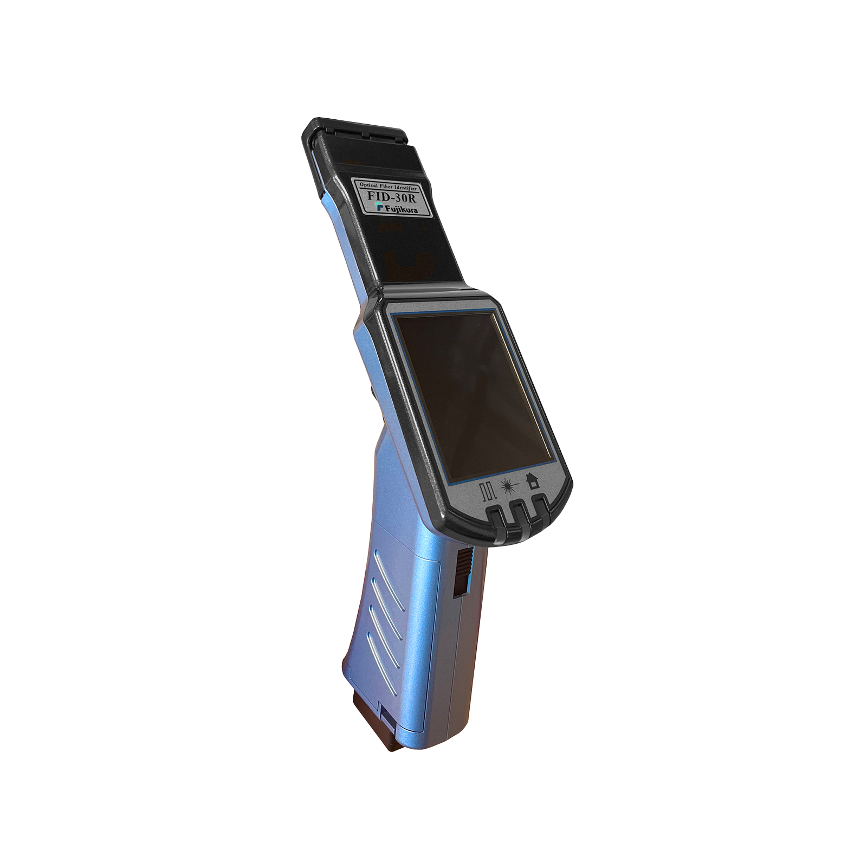

Description
Handheld fiber identifier with integrated optical power meter. The FID-30R determines whether light is running over a single-mode fiber without interrupting the connection: the fiber is slightly bent in the plunger and the leaking light is measured. The device recognizes a tone signal (270 Hz, 1 kHz, 2 kHz), traffic light (CW) and ONU signals, and shows the estimated power in dBm and the direction of the signal. Suitable for 0.25 mm fiber, ribbon fiber up to 12 fibers and fiber cord from 1.1 to 3 mm.

Brand
Fujikura

Versions
M80000360 | Fiber identifier, 30R, incl. power meter, Fujikura (FID-30R)
M80000370 | Fiber identifier, 31R, Fujikura (FID-31R)

Identifier mode screen
Part | Function
Battery indicator | Shows the battery charge level.
On/off button | Hold for a few seconds to switch off the identifier.
PM (FID-30R only) | Switch to power meter mode.
TONE | Measurement result of the tone signal, with frequency and optical power (dBm).
TRAFFIC | Measurement result of the data traffic, with optical power (dBm).
ONU (FID-30R/31R) | Measurement result of the ONU light, with optical power (dBm). Not available on the FID-32R.
Direction arrow | Direction in which the signal runs.
MENU | To the menu.
ZERO | Zero setting.

Power meter mode screen (FID-30R only)
Part | Function
ID | Back to identifier mode.
Wavelength | Set measuring wavelength (e.g. 1550nm).
Optical power | Measured power (e.g. -20.00 dBm). ABS stands for absolute value.
Detected signals | Symbols of the detected signals: CW, 270Hz, 330Hz, 1kHz, 2kHz.
MENU | To the menu.
REF | Switch to relative value display.
λ | Change measuring wavelength.

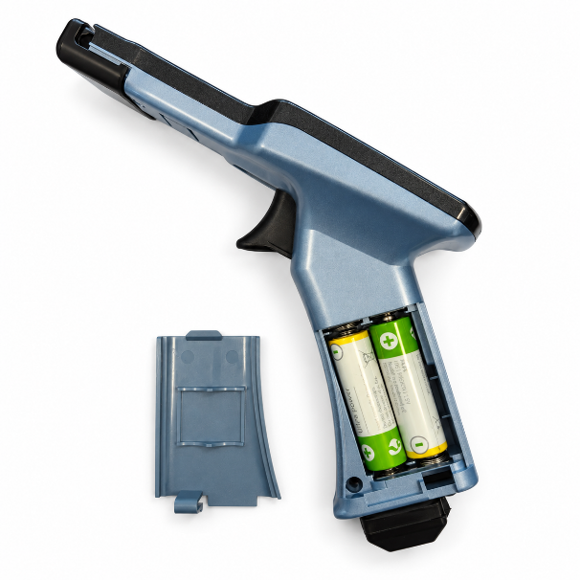 | - Open the battery compartment of the fiber identifier and insert the batteries according to the indicated polarity (+ and −). Then close the battery compartment.
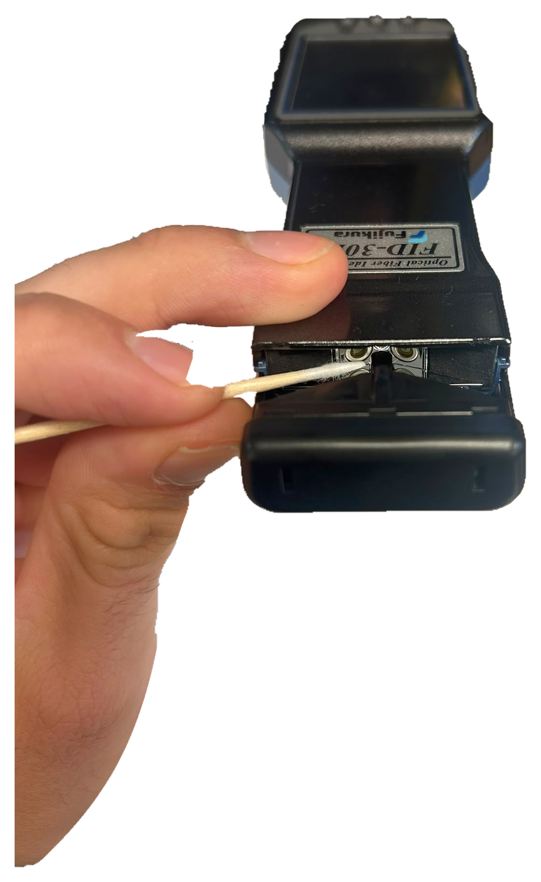 | - Before use, check that the optical detector is clean. With a dirty detector, the identifier cannot detect the leaking light from the bent fiber. If necessary, clean the detector with a cotton swab with alcohol.
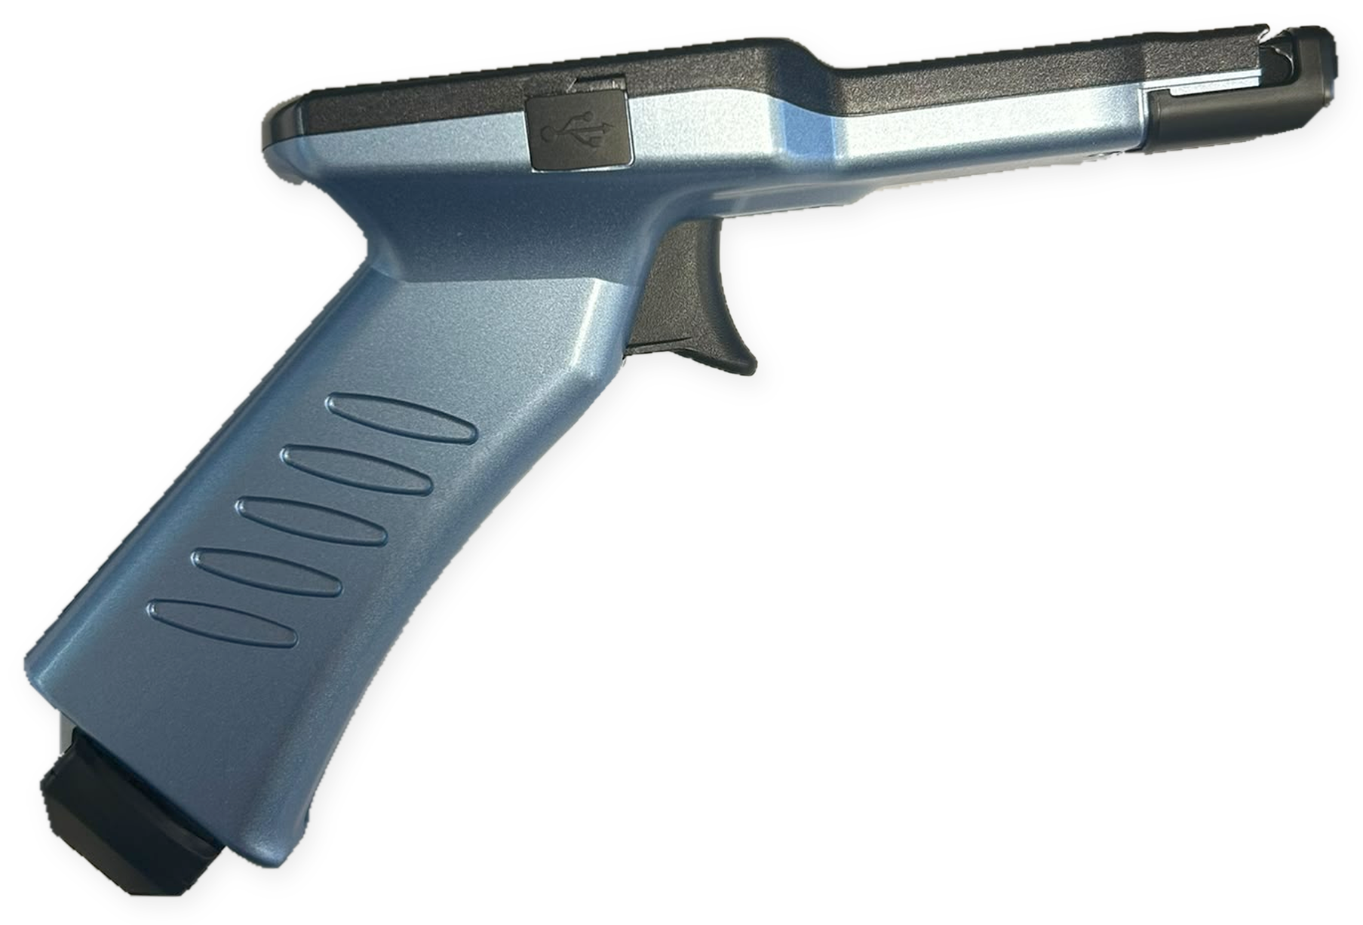 | - Pull the trigger without clamping a fiber.
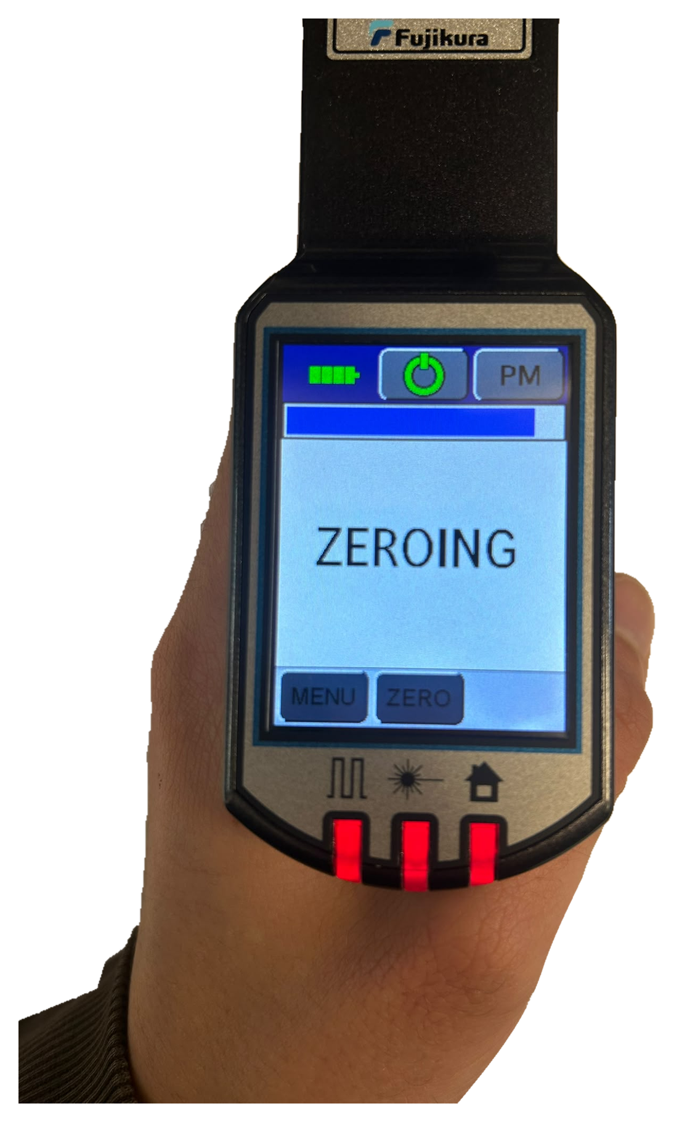 | - With the trigger pulled, tap ZERO on the screen. Do not release the trigger during zero setting.
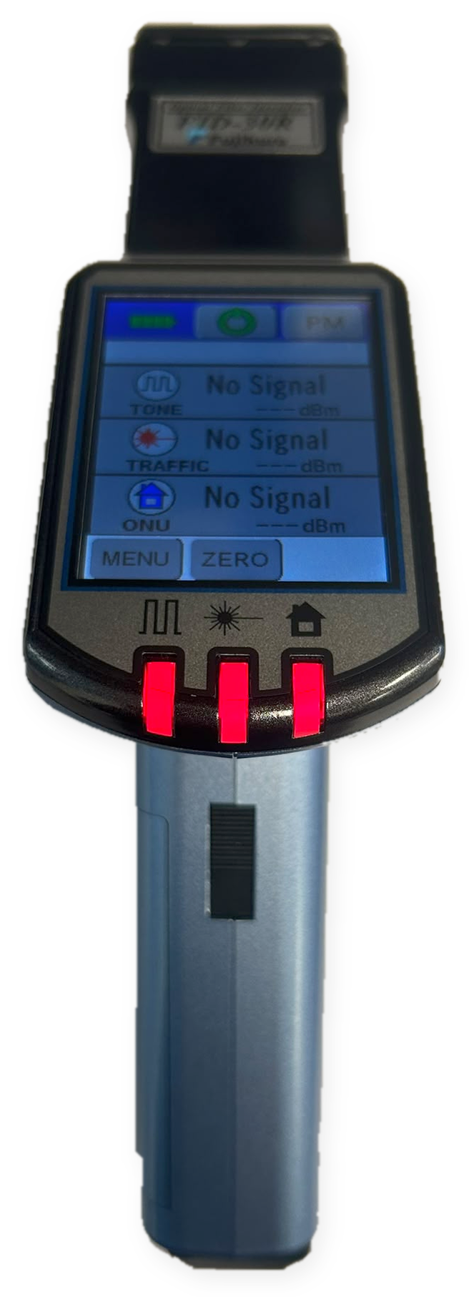 | - After zero setting, check that all LEDs light up red.

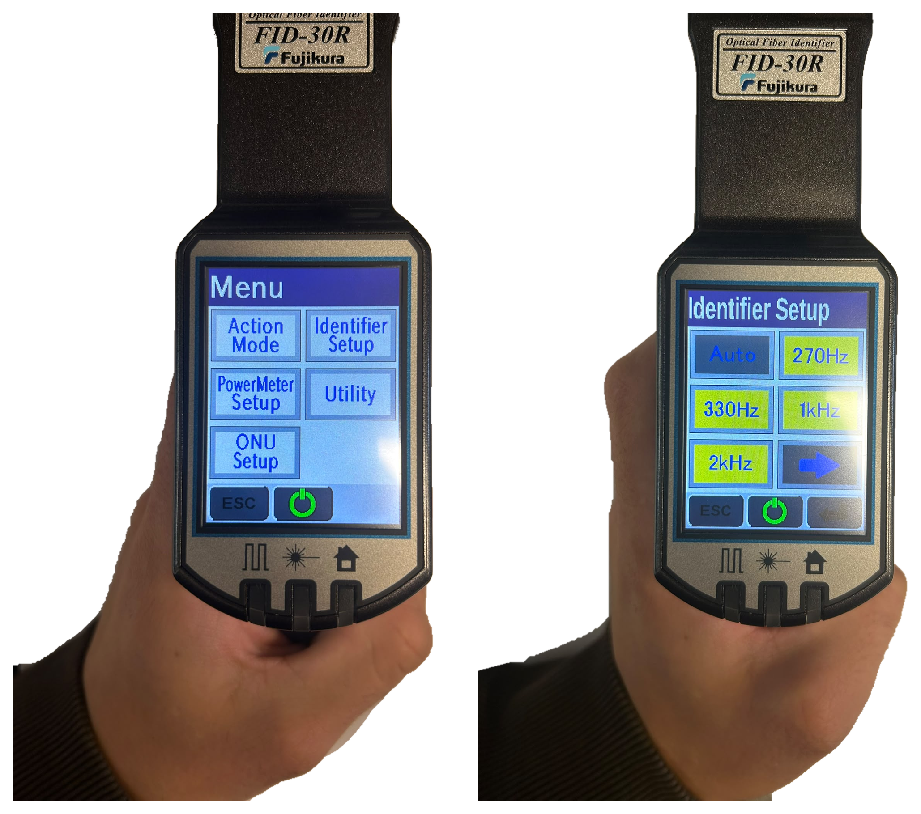 | - Tap MENU and then Identifier Setup and check the measuring mode. If you know which tone signal is used, select that signal (270Hz, 330Hz, 1kHz or 2kHz) instead of Auto. This prevents incorrect detection.  Note: ONU detection is not available on the FID-32R.

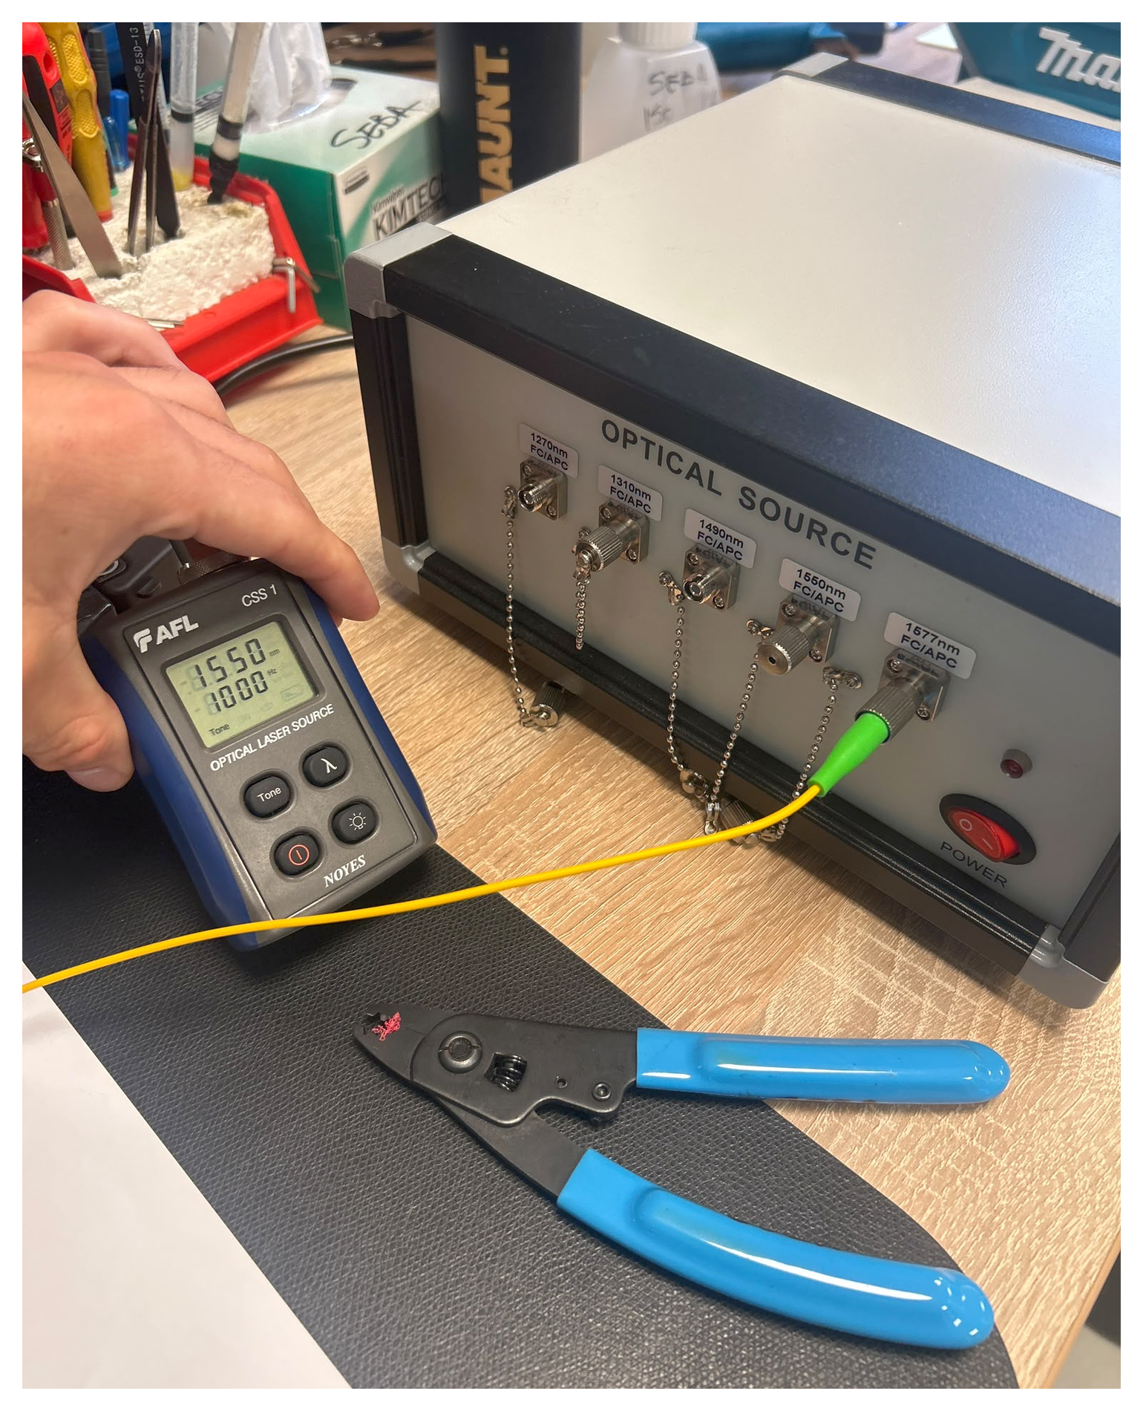 | - Make sure there is a tone signal or light source on the fiber so that it can be identified. In the image, an optical source was used for this in the test room.
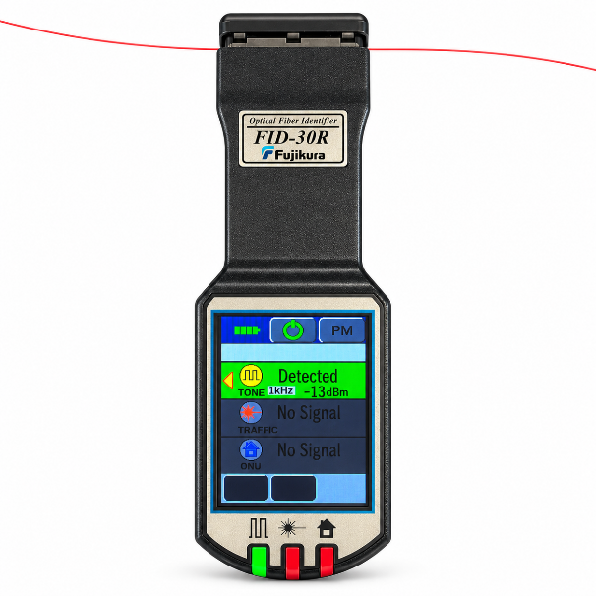 | - Clamp the fiber in the identifier by pulling the trigger and hold the fiber. Read the measurement result on the screen (see the examples below).
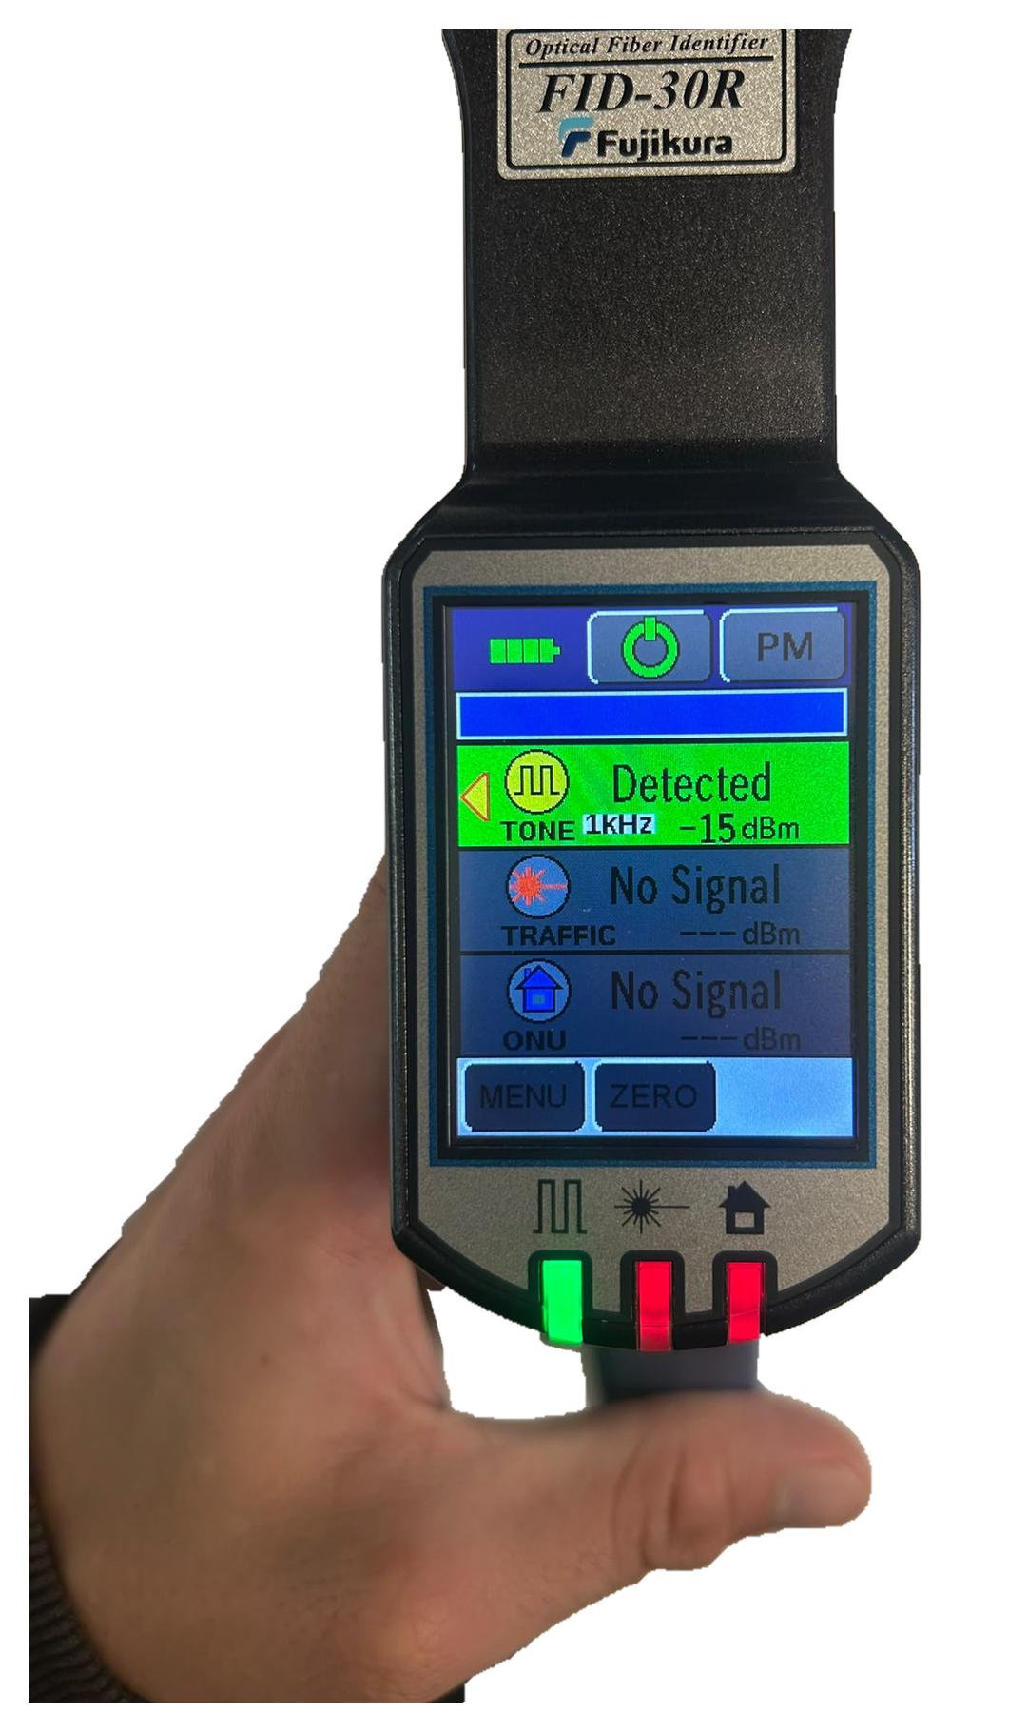 | - Tone signal detected: the background at TONE turns green, with the frequency of the signal (e.g. 1kHz or 2kHz). The arrow indicates the direction of the signal.
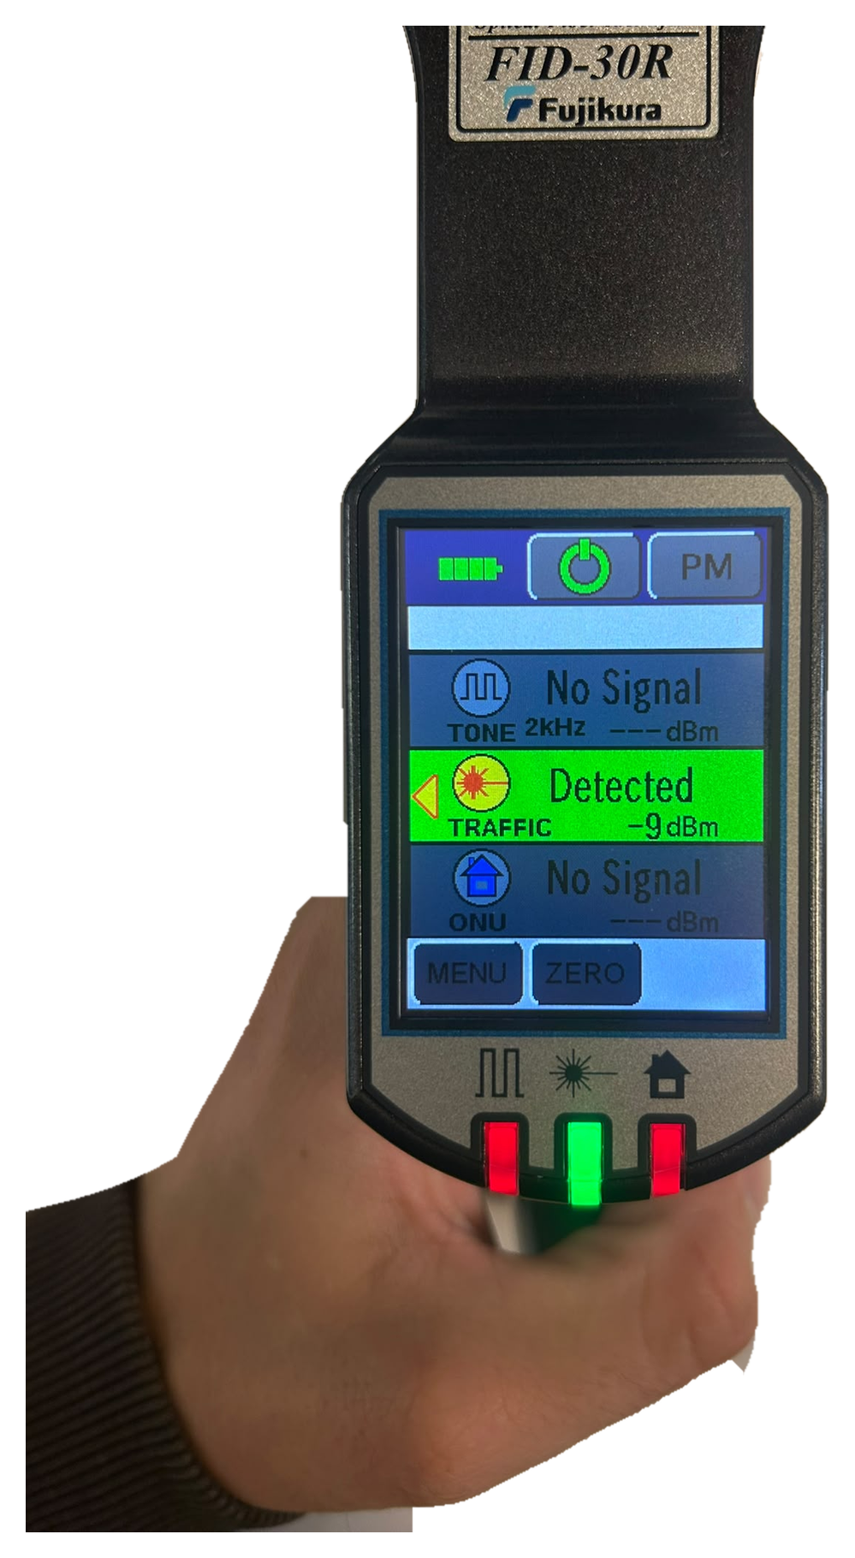 | - Data traffic (traffic light) detected: the background at TRAFFIC turns green. The arrow indicates the direction of the signal.
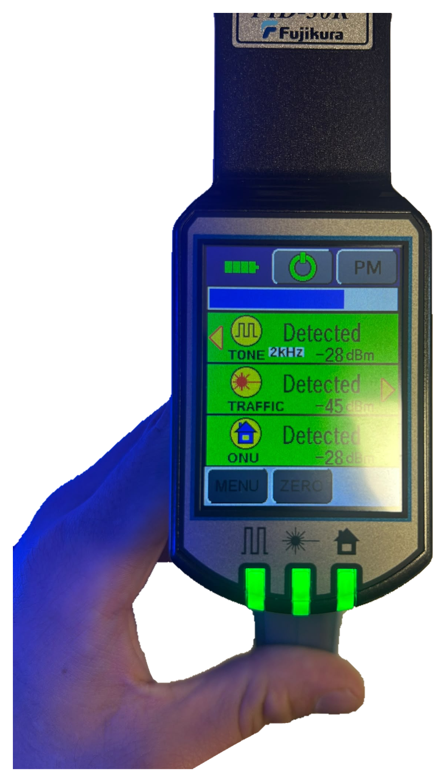 | - Note: external light, such as sunlight, UV light or lamp light, interferes with the identifier. The measurement result is then unreliable and both direction arrows may light up at the same time. Therefore measure without bright external light on the fiber wherever possible.
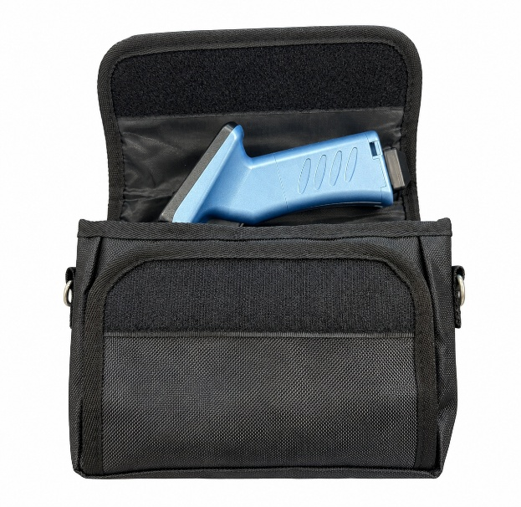 | - Hold the on/off icon for a few seconds to switch on the fiber identifier.

